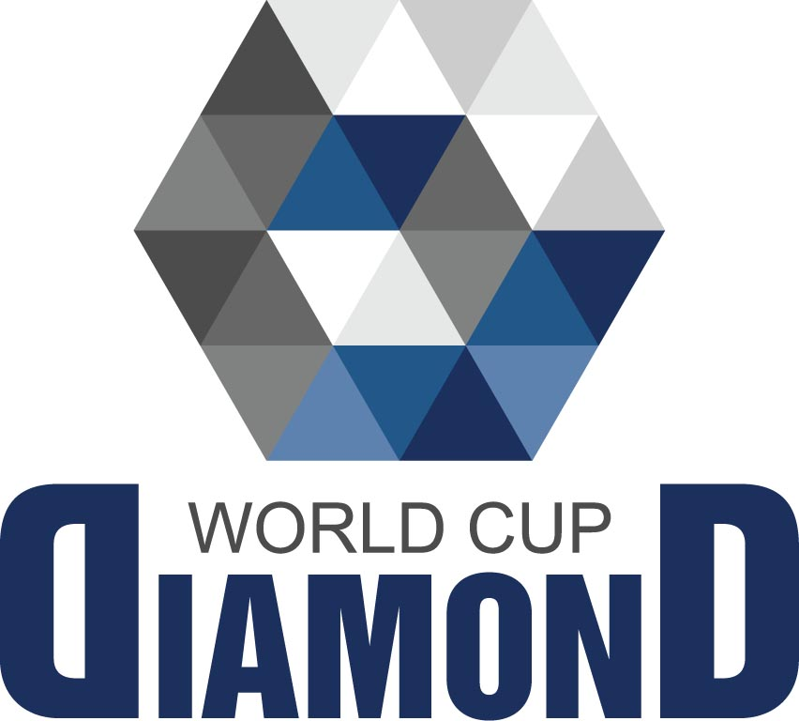
WORLD CUP diamond-2025
Kickboxing WPKA

5-10 October, 2025 Chuvash Republic, Russia ____________________________________________________________
Tel. +74957891500,
E-mail: kickboxingwpka@gmail.com

Country ________________________________________________________
Team___________________________________________________________
Address _________________________________________________________
Representatives name ____________________________________________
Mobile phone __________________________ E-mail ___________________
WhatsApp:________________________________________________________

PLEASE BOOK

Price for 1 person per night, including breakfast | Person
Triple room, 40 euro
Double room 45 euro
Single room 55 euro

Sportsmen _____________ (persons)
Coach _________________ (persons)
Escort _________________(persons)
Total _________________

Arrival date ____________________ October 2025
Departure date _________________ October 2025

